# Exploratory Data Analysis (EDA) Summary

## Transaction Amount Distribution

The distribution of transaction amounts helps us detect normal spending ranges and identify unusually high-value transactions.

![Transaction Amount Distribution](amount_distribution.png)

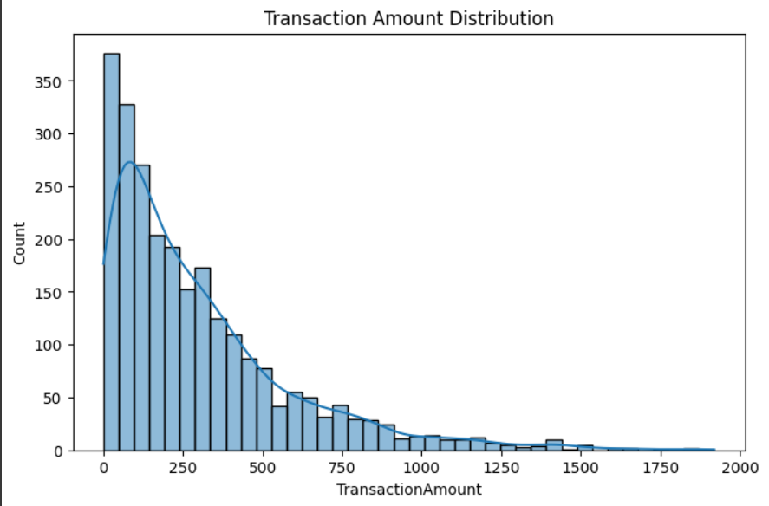

## Transactions by Channel

This chart shows how customers perform transactions across different channels (e.g., Mobile, ATM, Online). Channels with higher counts represent customer preferences.

![Transactions by Channel](channel_count.png)

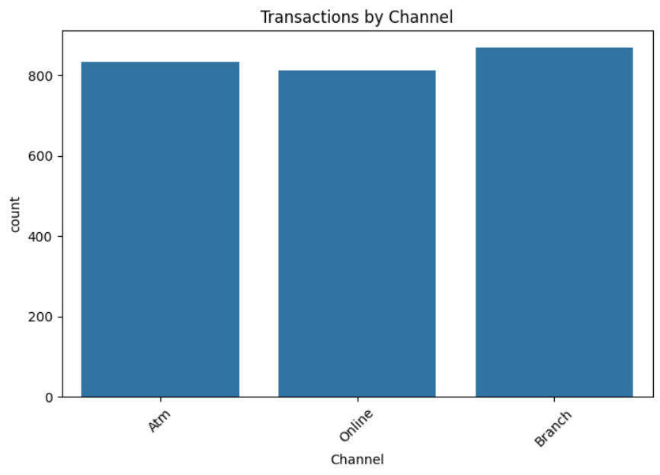

## Transactions by Type

Here we see which transaction types are most common. Certain types, such as transfers, could be more vulnerable to fraud than others.

![Transactions by Type](type_count.png)

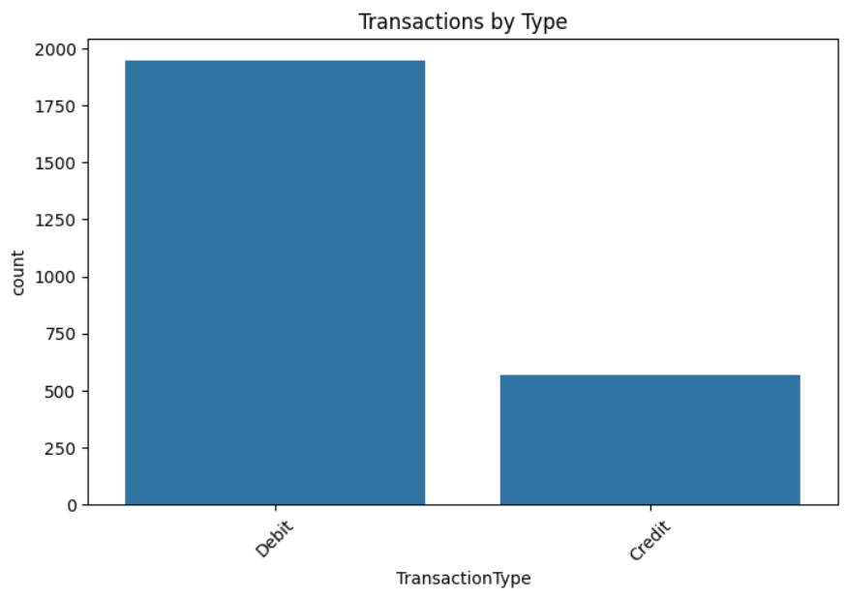

## Transactions by Hour

Transactions are grouped by the hour of the day. Spikes at unusual hours (like midnight) could indicate suspicious activity.

![Transactions by Hour](hour_count.png)

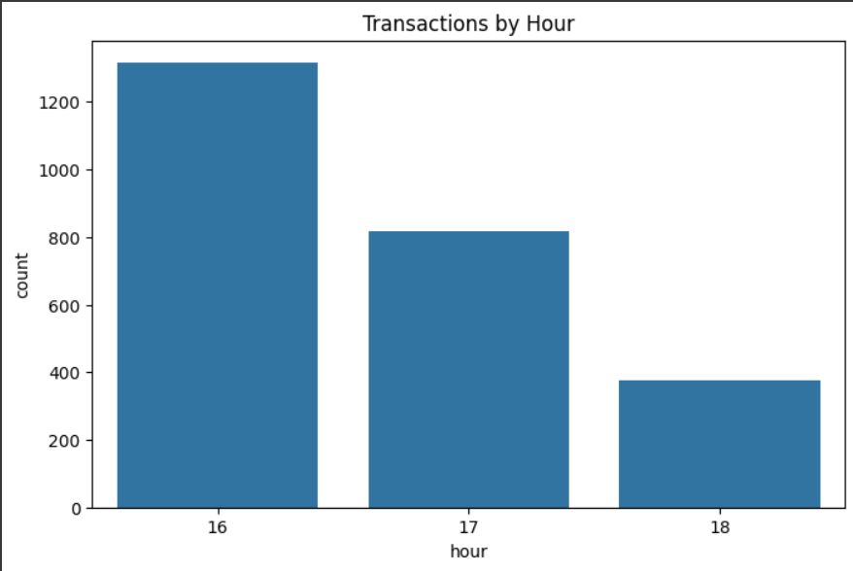

## Transactions by Weekday

This shows how transaction activity varies across weekdays. Patterns here may indicate business vs personal transaction behavior.

![Transactions by Weekday](weekday_count.png)

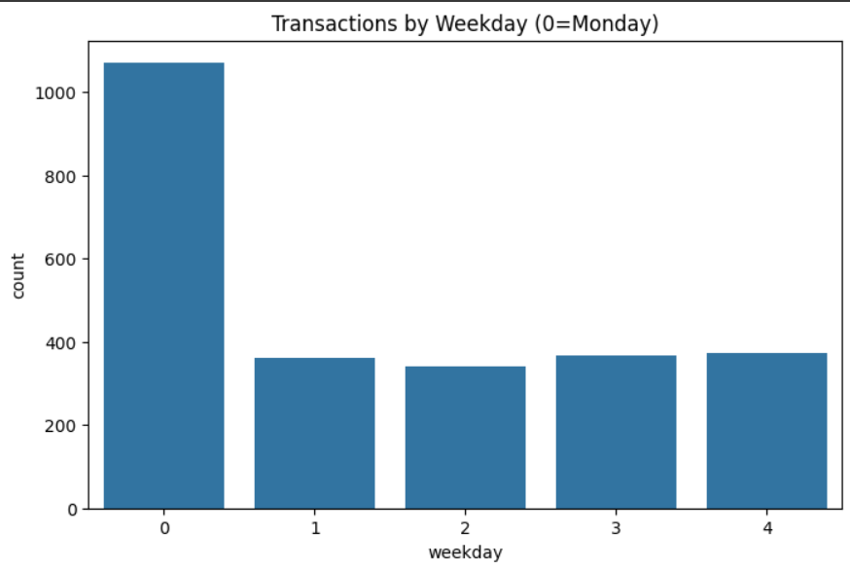

## Correlation Heatmap

The heatmap below shows correlations between numerical variables. High correlation may suggest redundancy or strong dependency between features.

![Correlation Heatmap](correlation_heatmap.png)

